The District of Gelligaer

THE SACRED THREE DAYS

*Over the next three days we will follow the drama of our redemption played out in one act of worship comprising three celebrations.*



**EASTER**

***When we celebrate Jesus’ resurrection to new life, his victory over death and evil, a victory he shares with us for all time.***

***...on the first day of the week, at the first sign of dawn, they went to the tomb……***

**EASTER DAY**

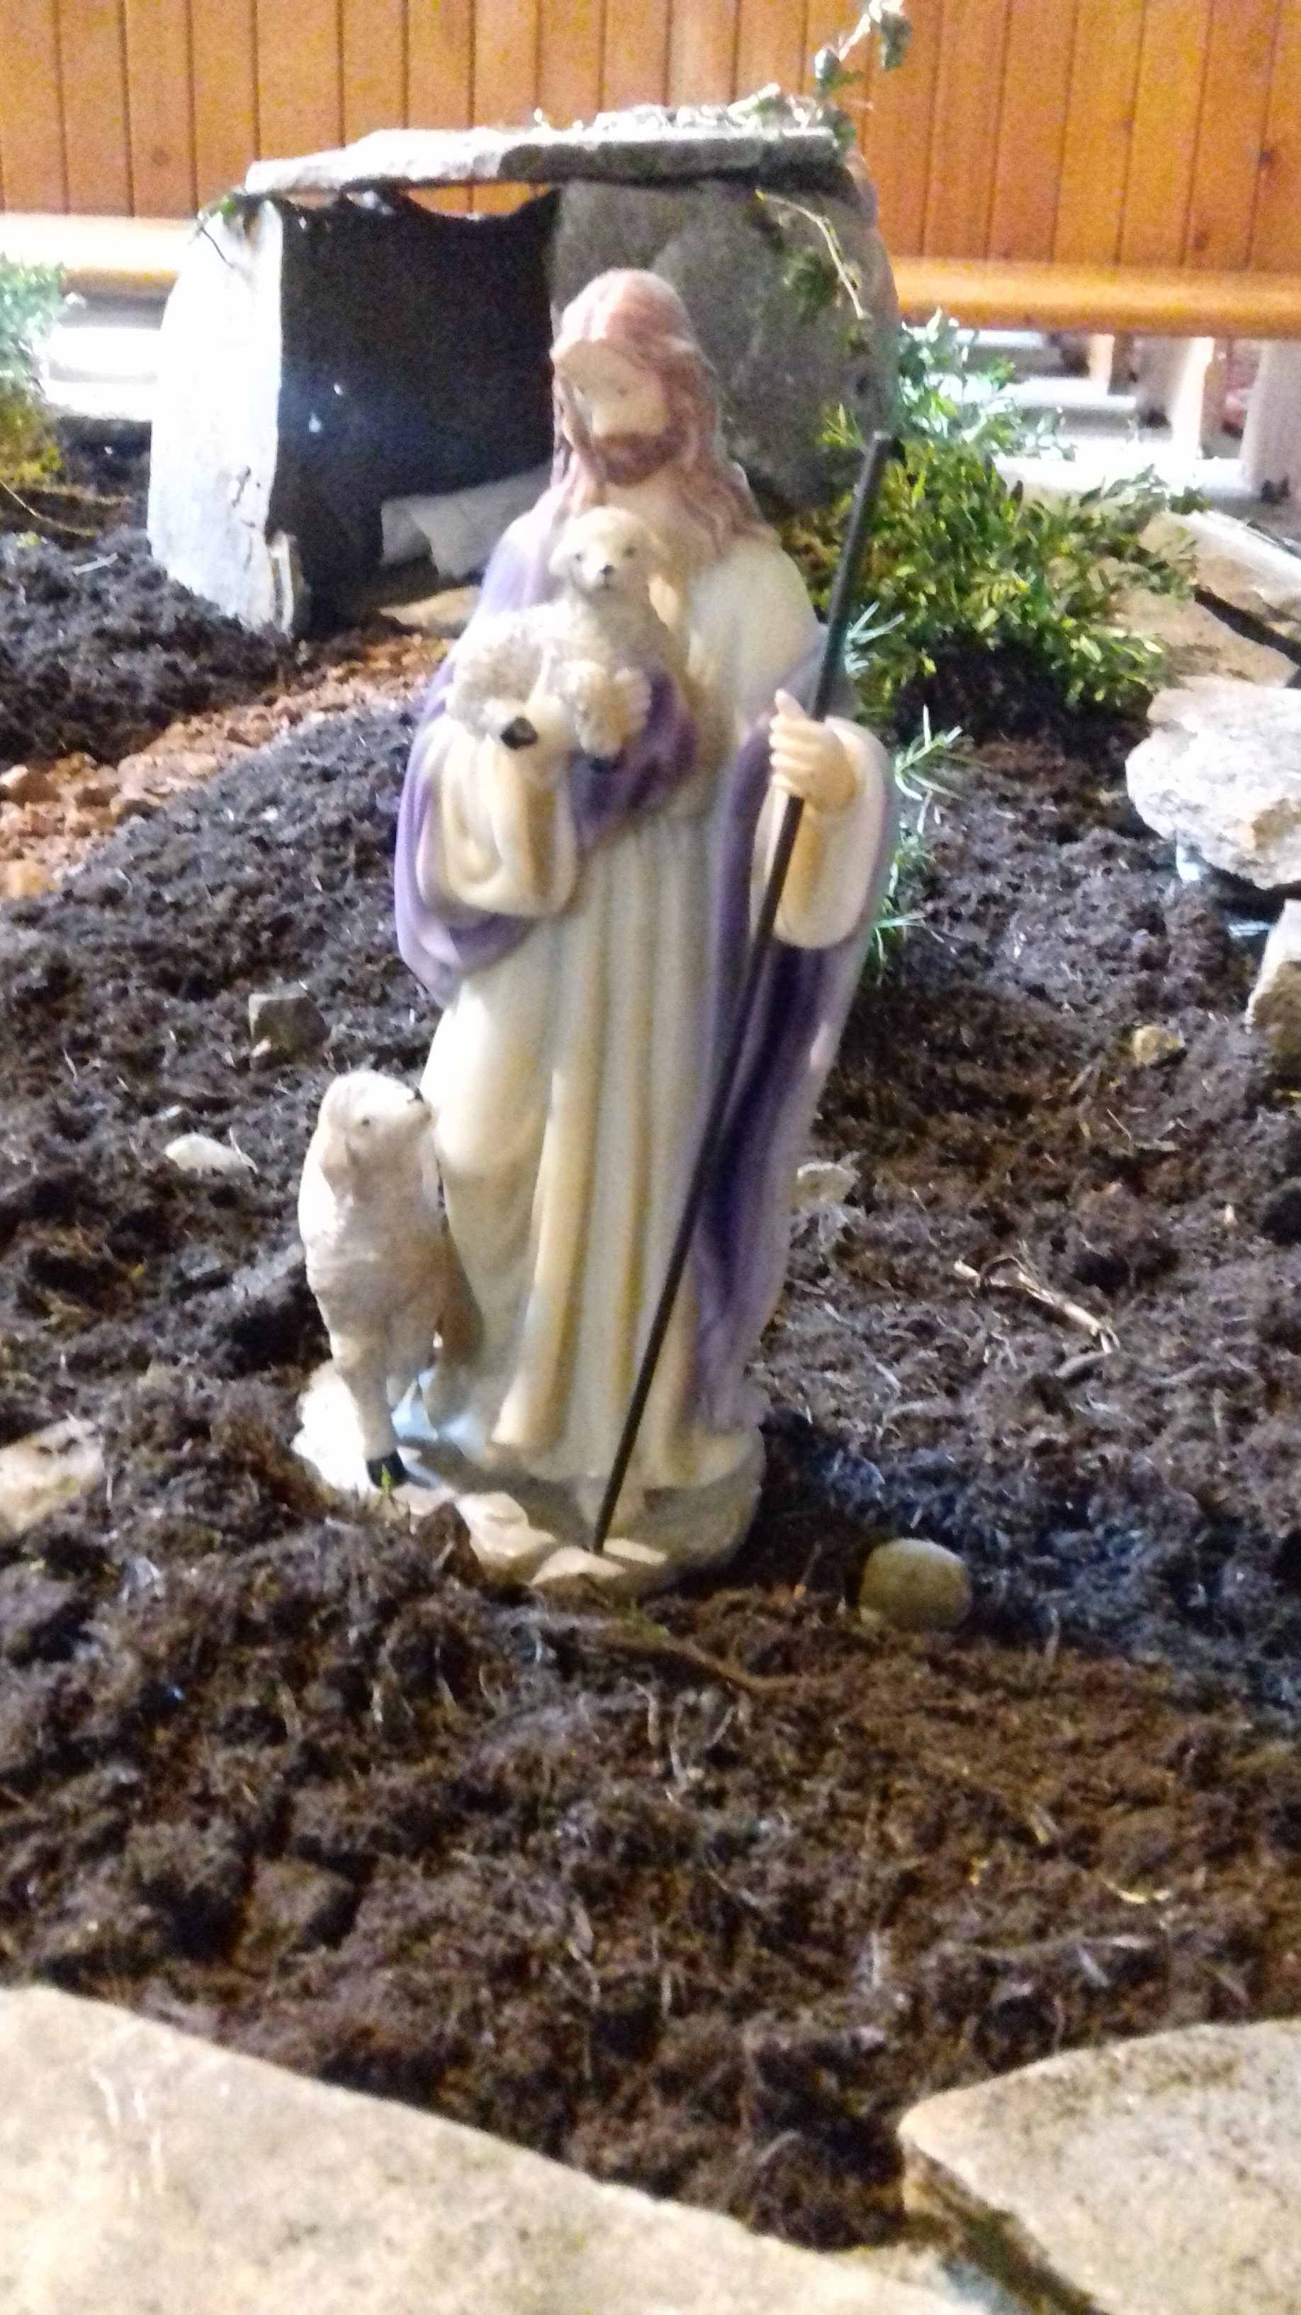

My friends, on this most holy day, in which our

Lord Jesus Christ passed over from death to life,

the Church invites her members to gather in prayer.

For this is the Passover of the Lord, in which we

share in his victory over death.

*Today we celebrate the resurrection*

*of our Lord Jesus Christ,*

*we praise the risen Christ who is our life*

*and whose triumph over death*

*we proclaim to all the world.*

In the name of the Father, and of the Son, and of the Holy Spirit. **Amen.**

Alleluia! Christ is risen. **He is risen indeed. Alleluia!**

Father of glory, holy and eternal, look upon us now in power and mercy. May your strength overcome our weakness, your radiance transform our blindness, and your Spirit draw us to that love shown and offered to us by your Son, our Saviour Jesus Christ. Amen.

Lord Jesus, you raise the dead to life in the Spirit. **Lord, have mercy.**

Lord Jesus, you bring pardon and peace to the sinner. **Christ, have mercy.**

Lord Jesus, you give light to those in darkness. **Lord, have mercy.**

May Almighty God have mercy upon us, forgive us our sins and bring us to

everlasting life. Amen.

**Alleluia, alleluia, glory be to God on high;**

**Alleluia, to the Saviour who has gained the victory;**

**Alleluia to the Spirit, fount of love and sanctity;**

**Alleluia, Alleluia, to the Triune Majesty.**

**Collect:**

Lord of all life and power, who through the mighty resurrection of your Son overcame the old order of sin and death to make all things new in him; grant that we, being dead to sin and alive to you in Jesus Christ, may reign with him in glory, to whom with you and the Holy Spirit be praise and honour, glory and light, now and in all eternity. Amen.

**A reading from the Book of Acts**  **10. 34-43**

Then Peter began to speak to them: ‘I truly understand that God shows no partiality, but in every nation anyone who fears him and does what is right is acceptable to him. You know the message he sent to the people of Israel, preaching peace by Jesus Christ - he is Lord of all. That message spread throughout Judea, beginning in Galilee after the baptism that John announced: how God anointed Jesus of Nazareth with the Holy Spirit and with power; how he went about doing good and healing all who were oppressed by the devil, for God was with him. We are witnesses to all that he did both in Judea and in Jerusalem. They put him to death by hanging him on a tree; but God raised him on the third day and allowed him to appear, not to all the people but to us who were chosen by God as witnesses, and who ate and drank with him after he rose from the dead. He commanded us to preach to the people and to testify that he is the one ordained by God as judge of the living and the dead. All the prophets testify about him that everyone who believes in him receives forgiveness of sins through his name.’

This is the Word of the Lord. **Thanks be to God.**

**Psalm: 118: 19-24 Response: O give thanks to the Lord, for he is good.**

Open to me the gates of righteousness:

that I may enter and give thanks to the Lord.

This is the gate of the Lord: The righteous shall enter through it. **(R)**

I will give thanks to you, for you have answered me:

and have become my salvation.

The stone which the builders rejected: has become the chief cornerstone. **(R)**

This is the Lord’s doing: and it is marvellous in our eyes.

This is the day that the Lord has made: we will rejoice and be glad in it. **(R)**

**A reading from the letter of Paul to the Colossians 3. 1-4**

So if you have been raised with Christ, seek the things that are above, where Christ is, seated at the right hand of God.Set your minds on things that are above, not on things that are on earth,for you have died, and your life is hidden with Christ in God.When Christ who is your life is revealed, then you also will be revealed with him in glory.

This is the Word of the Lord. **Thanks be to God.**

**Gospel Acclamation:**

**Alleluia! Alleluia! Alleluia!**

Do not be afraid, He is not here for he has been raised**.**

**Alleluia! Alleluia! Alleluia!**

**A reading from the Gospel according to Saint Matthew**  **28. 1-10**

**Glory to you, O Lord.**

After the sabbath, as the first day of the week was dawning, Mary Magdalene and the other Mary went to see the tomb.And suddenly there was a great earthquake; for an angel of the Lord, descending from heaven, came and rolled back the stone and sat on it.His appearance was like lightning, and his clothing white as snow.For fear of him the guards shook and became like dead men.But the angel said to the women, ‘Do not be afraid; I know that you are looking for Jesus who was crucified.He is not here; for he has been raised, as he said. Come, see the place where he lay.Then go quickly and tell his disciples, “He has been raised from the dead, and indeed he is going ahead of you to Galilee; there you will see him.” This is my message for you.’So they left the tomb quickly with fear and great joy, and ran to tell his disciples.Suddenly Jesus met them and said, ‘Greetings!’ And they came to him, took hold of his feet, and worshipped him.Then Jesus said to them, ‘Do not be afraid; go and tell my brothers to go to Galilee; there they will see me.’

This is the Gospel of the Lord. **Praise to you, O Christ.**

**Meditation: “This is my friend in whose sweet praise**

**I all my days could gladly spend.”**

Alleluia! Christ is risen” Today God’s song of love for his world reaches its glorious climax in the most wonderful way. The disciples were in despair, Jesus was dead, his body entombed. Confused and afraid the disciples felt adrift in the world. All seemed lost. But on the first day of the week, Matthew tells us, Mary Magdalene and the other Mary went to see the tomb. They were both amazed and afraid to be greeted by an angel who had rolled away the stone from the tomb. He told them the wonderful news, “Do not be afraid,” he said, “I know that you are looking for Jesus who was crucified. He is not here; for he has been raised as he said.” Filled with a feeling of both fear and great joy the women ran to tell the disciples the wonderful news. As they ran Jesus met them and spoke to them. The women fell at his feet in amazement and worshipped him before he sent them to tell his disciples to meet him in Galilee. It was more than they could have ever imagined. Jesus was alive. His song of love resounding once again throughout the world. Nothing, not even the combined songs of betrayal, abandonment, hatred and rejection, not even the song of death could keep Jesus from singing his song of love for the world. The resurrection of Jesus completed the victory of love over death. Nothing, as S. Paul tells us, can now keep us from the love of Christ. The resurrection of Jesus Christ is the victory of hope over despair, of peace over conflict and reconciliation over division. The hope of the disciples was realised and their despair gave way to joy. The peace of Christ overcame the conflict he faced from those who had opposed him. In his resurrection He reconciled God and his people who had become separated by sin. By his resurrection Jesus brings the light of hope and love to the world and to all our lives and the world is in so much need of hope at this time. The wonderful news of Easter is that Jesus is with us, we are not alone, he will not abandon us. Wherever we are, whatever the circumstances of our lives nothing can separate us from him or his love. Jesus’ song of love for us is eternal. Today we reply to the good news that Jesus is alive and with us with our own glorious song of love and joy “This is my friend in whose sweet praise I all my days could gladly spend!”

**Intercessions:**

We pray for the Church throughout the world, for the leaders of the Church among them Andrew our Archbishop and Mary our Bishop. We pray for the clergy and people of our diocese and for our own ministry area; that the Church may faithfully work with Christ to proclaim the saving love of God to the world.

Lord in your mercy, **Hear our prayer.**

We pray for the peoples of the world, that the joy of the Resurrection may be known throughout the world bringing reconciliation where there is division, peace where there is conflict and hope where there is despair.

Lord, in your mercy….. **Hear our Prayer**

We pray for the people of our nation, for all who live, work and worship in our parish. We pray for family, friends and neighbours. We give thanks for all giving freely of their time to help and serve the needs of the vulnerable.

Lord, in your mercy…...**Hear our Prayer**

We pray for all who are in need, for the sick, for all who are lonely, isolated and separated from family and friends. We pray for all who are bereaved and those who are distressed. We hold before God those known to us in need at this time and all whose names are recorded in our parish intercession books. May the Good News of the resurrection of Christ bring healing, peace and the hope of restored life to all who are troubled in body, mind or spirit.

Lord, in your mercy……**Hear our Prayer**

We pray for all who have died, for our own departed loved ones, for all the recently departed and for those whose anniversary of death falls at this time. May they rest in the peace and joy of heaven in the company of all the saints.

Lord, in your mercy…….**Hear our Prayer**

We bring all our prayers for ourselves, our families, friends and neighbours and all for whom we pray to our heavenly Father:

**Our Father,**

**who art in heaven,**

**hallowed be thy name,**

**thy kingdom come,**

**thy will be done,**

**on earth as it is in heaven.**

**Give us this day our daily bread.**

**And forgive us our trespasses**

**as we forgive those who trespass against us.**

**And lead us not into temptation,**

**but deliver us from evil.**

**For thine is the kingdom, the power and the glory**

**for ever and ever. Amen.**

**The Peace:**

The risen Christ came and stood among his disciples and said, “Peace be with you!” They were overjoyed on seeing the Lord.

The peace of the Lord be always with you and those whom you love.

**And also with you,**

Let us pray:

**Living God, who for our redemption gave your only begotten Son to the death of the cross, and by his glorious resurrection have delivered us from the power of our enemy: grant us so to die daily to sin, that we may evermore live with him in the joy of his risen life; through Jesus Christ our Lord. Amen.**

**The Blessing**

Almighty God, who through the resurrection of our Lord Jesus Christ has given us the victory, give you joy and peace in believing and the blessing of God almighty, the Father, the Son and the Holy Spirit, be among you and remain with you always. Amen.

Alleluia! Christ is risen. **He is risen indeed. Alleluia!**

*The Word of the Lord and other prayers: Copyright Church in Wales publications.*

*The Church in Wales Word of the Lord 2011 copyright © Church in Wales publications 2011*